City of Grosse Pointe Park
Rules of the City Council and Code of Conduct Adopted: January 12, 2026
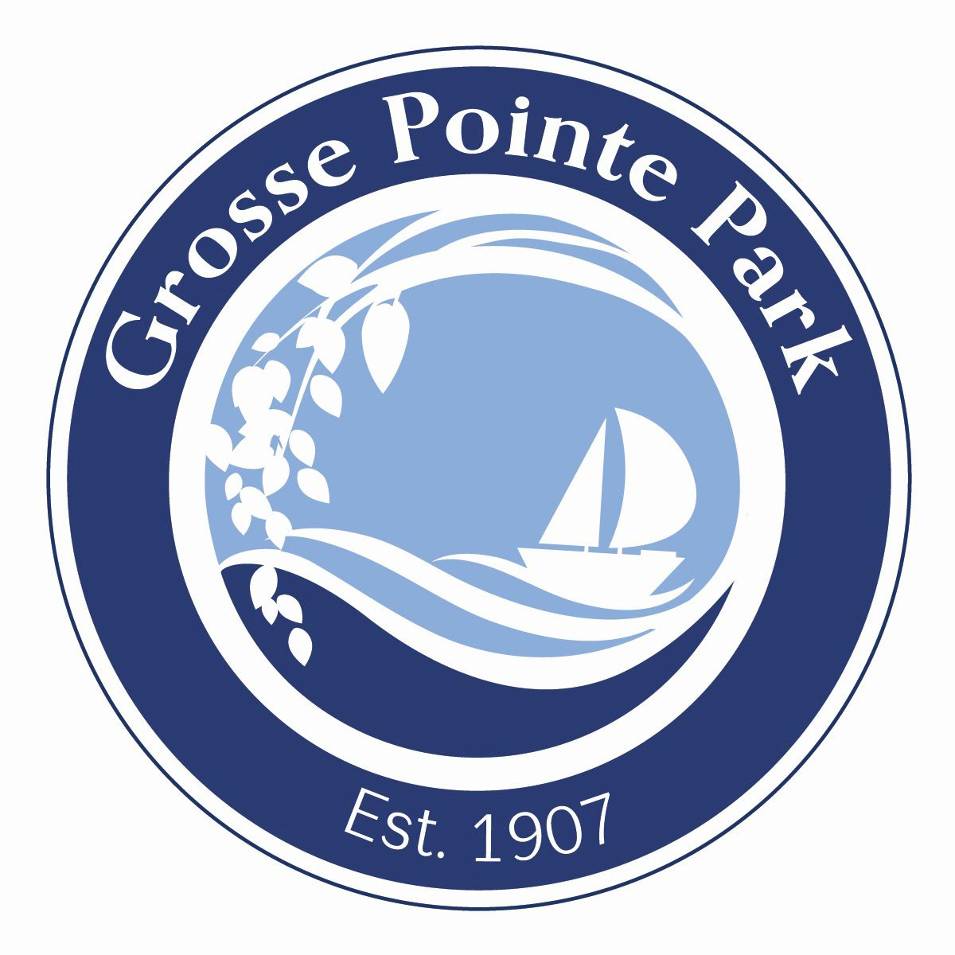

Table of Contents
Statement of Purpose, Council-Manager Government Explanation, & Regular Meetings 2
Posting Requirements for Regular and Special Meetings & Closed Meetings 4
Agenda, Setting an Agenda, Consent Agenda, Voting & Discussion, Minutes & Citizen Participation 5
Disorderly Conduct & Committee Assignments 8
City of Grosse Pointe Park Council Code of Conduct 9
Public Relations, City Council Relations with City Staff/Officials 9
Council Conduct with One Another 11
City Council Relationship with City Commissions and Committees, & Council Member Representation to Other Agencies and Groups 12
General Provisions 12
Compliance and Enforcement 13
Robert’s Rules of Order Reference Sheet 14
References 16

Statement of Purpose
The residents and businesses of Grosse Pointe Park are entitled to have a fair, ethical, and accountable municipal government which has earned the public’s full confidence for integrity. The City of Grosse Pointe Park’s strong desire to fulfill this mission requires that:
- public officials, both elected and appointed, comply with both the letter and spirit of the laws and policies affecting the operations of government.
- public officials be independent, impartial, and fair in their judgment and actions.
- public office be used for the public good, not for personal gain; and
- public deliberations and processes be conducted openly, unless legally confidential, in an atmosphere of respect and civility.
To this end, the City of Grosse Pointe Park has adopted these Rules of the City Council and Code of Conduct for elected officials and members of appointed boards, commissions, and committees to promote public confidence in the integrity of local government and its effective and fair operation.

Council-Manager Government
The City of Grosse Pointe Park functions under the Council-Manager form of government, the fastest growing form of government in the United States today. According to surveys by the International City/County Management Association (ICMA), this form of government has grown from 48% usage in 1996 to 55% usage in 2006. It is also the most prevalent for populations over 10,000 and is used by more cities, villages, townships, and counties than any other form. The roots of the Council-Manager form of government date as far back as the early 1900s.
The Council-Manager form of government is based on the separation of roles and responsibility between the City Council and the City Manager for the effective and efficient investigation, deliberation, and delivery of services. The City’s goals are best achieved when there is an open, dynamic, and cooperative working relationship built on trust between the City Council as a body, the City Council Members as individuals, and the Manager. This relationship is further enhanced by the understanding that each person is conducting themselves in their role in a reasonable, responsible, and accountable manner while working together in the best interest of the citizens of Grosse Pointe Park. It is important that everyone involved has a shared understanding of the roles of each involved person and body.

City Council
The City Council legislates through ordinances and resolutions but may not exceed the scope of authority the body is granted through the City’s charter and state law. In a council-manager government, the mayor and council members are the leaders and policy makers elected to represent the community. The Mayor acts as the Chair of the body but does not have veto power and is considered a voting member of the body like the other council members.
The City Council acts as policy makers and long-term and short-term goal setters. They focus on policy issues that are responsive to citizens' needs and wishes. The City Council is also responsible for approving the City’s budget and all capital improvement plans.

A City Council member is a goal setter who helps develop a vision for the community and helps establish goals and milestones. Council members must remember they are elected to make decisions as a collective body, not to act as individuals or apart from the council.

City Manager
The City Manager is the chief administrative officer for the City of Grosse Pointe Park. Major responsibilities include oversight of preparation of the annual budget and long-range financial planning, supervision of all City departments, coordination and development of programs and services and the implementation of City Council's strategic priorities and policy decisions. The City Manager is also responsible for recruiting, hiring (unless approval of a position is by the City Charter), and supervising staff; and serving as the council’s chief adviser.
The City Manager may make policy recommendations to the council, but the council may or may not adopt them and may modify the recommendations. The City Manager also provides regular reports and updates to the City Council on these items. The manager is bound by whatever official action is taken by the Council.
The City Manager reports to and is appointed by the City Council under the Council-Manager form of government.

Regular Meetings
- Regular meetings of the City Council will be held once a month beginning at 7:00 p.m., local prevailing time, in the Council chambers, City Hall, 15115 E. Jefferson Ave., Grosse Pointe Park, Michigan, unless special circumstances, e.g. holidays, closing of City Hall, etc., warrant otherwise.

- All meetings shall be governed by and subject to all applicable provisions of the City Charter and relevant Michigan Statutes, including, but not limited to, the Open Meeting Act, MCL 15.261 et seq.; MSA 4.1800 (1) et seq. as amended.

- The Mayor and City Council have a reasonable knowledge of the rules and conduct the council has adopted. This will keep the meeting moving smoothly and efficiently, with a clear indication of each item’s disposition.

- The rules of parliamentary procedure as contained in Robert's Rules of Order, most recent edition, shall govern Council meetings in all cases to which they are applicable, provided they are not in conflict with these Rules, the Ordinances and Charter of the City of Grosse Pointe Park, and/or any applicable state or federal law.

- The Mayor shall preserve order and decorum and may speak to points of order in preference to other council members. The Mayor shall decide all questions arising under this parliamentary authority, subject to appeal and reversal by a majority of the councilmembers present.

- Any member may appeal a ruling of the Mayor to the council. If the appeal is seconded, the member making the appeal may briefly state the reason for the appeal and the Mayor may briefly state the ruling. There shall be no debate on the appeal and no other member shall participate in the discussion. The question shall be, “Shall the decision of the Mayor be sustained?” If the majority of the members present vote “aye,” the ruling of the Mayor is sustained; otherwise it is overruled.
- The Mayor, or in his/her absence or direction, the Mayor Pro-Tem shall at the fixed time take the Chair for the convening of the City Council to order. Upon the appearance of a quorum, the Council shall be in session. If both the Mayor and Mayor Pro-Tem are absent from a meeting, the Council person having served the longest uninterrupted term of office as a Council member shall take the Chair for the purpose of calling the Council to order.

Requirements for Regular, Special and Closed-Door Meetings

- Within 10 days after the December meeting of the City Council, a public notice stating the dates, times, and places of the regular monthly council meetings for the following calendar year will be posted at the City Offices and the City’s website.
- By Charter Section 6.2. Special meetings. Special meetings shall be called by the Clerk on the written request of the Mayor, the City Manager or any two members of the Council on at least twenty-four hours written notice to each member of the Council served personally or left at his usual place of residence; but a special meeting may be held on shorter notice if all members of the Council are present or have waived notice thereof in writing. State law reference-Open meetings Act, MCL 15.261 et seq., MSA 4.1800(,11) et seq

Closed Meetings Purpose
Meeting in closed session – a public body may meet in a closed session only for one or more of the permitted purposes specified in section 8 of the OMA. The limited purposes for which closed sessions are permitted include, among others:
  - To consider the dismissal, suspension, or disciplining of, or to hear complaints or charges brought against, or to consider a periodic personnel evaluation of, a public officer, employee, staff member, or individual agent, if the named person requests a closed hearing.
  - For strategy and negotiation sessions connected with the negotiation of a collective bargaining agreement if either negotiating party requests a closed hearing.

  - To consider the purchase or lease of real property up to the time an option to purchase or lease that real property is obtained.

  - To consult with its attorney regarding trial or settlement strategy in connection with specific pending litigation, but only if an open meeting would have a detrimental financial effect on the litigating or settlement position of the public body.
  - To review and consider the contents of an application for employment or appointment to a public office if the candidate requests that the application remain confidential. However, all interviews by a public body for employment or appointment to a public office shall be held in an open meeting pursuant to this act.

  - To consider material exempt from discussion or disclosure by state or federal statute.52 But note – a board is not permitted to go into closed session to discuss an attorney's oral opinion, as opposed to a written legal memorandum.
A closed session must be conducted during an open meeting – section 2(c) of the OMA defines "closed session" as "a meeting or part of a meeting of a public body that is closed to the public." Section 9(1) of the OMA provides that the minutes of an open meeting must include "the purpose or purposes for which a closed session is held."

1. Calling Closed Meetings

At a regular or special meeting, the Council may call a closed session under the conditions outlined in Section 1, above. The vote and purpose(s) for calling the closed meeting shall be entered into the minutes of the public part of the meeting at which the vote is taken.

Agenda
The following shall be the form of the agenda for Council meetings:
- Roll Call of Council
- Pledge of Allegiance
- Approval of Consent Agenda
- Administration Reports (If applicable)
- Approval of Regular Agenda
- Public Comment (Agenda Items)
- Unfinished Business
- New Business
- Public Comment (Non-Agenda Items)
- Council Comment
- Closed Session
- Adjournment

Setting a Meeting Agenda
An agenda serves as the guide for conducting an official business meeting of the City Council or any other duly constituted body. The person responsible for setting the agenda is the Mayor in consultation with the City Manager.
City Council Members can request to have an item added to a city council meeting agenda at least 7 business days in advance of a scheduled meeting by contacting the Mayor and City Manager with an email request for a discussion topic. The request will be reviewed and considered by the Mayor and City Manager. The topic of discussion must have background documentation submitted to the Mayor and City Manager for why the request is being made. Being mindful the City Manager with Administration and the City Attorney will need time to research the pros and cons and provide any required legal opinion, as well allowing the public to be in attendance for that agenda item for those who so choose to listen and or participate during public comment of agenda items.

The meeting agenda and all supporting documents will be made available to Council and published online two business days in advance of the meeting on Thursday. Emergency items can be added to the agenda after two business days if necessary.
As part of every Council meeting, the City Council will set the Regular Agenda at the beginning of the meeting after the Consent Agenda has been approved and voted on.

Consent Agenda
  - A consent agenda may be used to allow the Council to act on numerous administrative or non-controversial items at one time. Included on the agenda can be non-controversial matters such as approval of minutes, payment of bills, approval of recognition resolutions, committee, and commission reports, administration reports etc. The consent agenda will be provided to the Council 5 business days before the scheduled meeting where the consent agenda will be used. Items may be added later if necessary to the consent agenda.
  - Upon request by any member of the council, an item shall be removed from the consent agenda and placed on the regular agenda for discussion. In order to move an item to the regular agenda, the request must be made via email to the Mayor, City Manager, and Clerk by 10am the Friday before the meeting.

Voting and Discussion
- A vote upon all ordinances and resolutions, and all subsidiary motions applied thereto, shall be taken by a roll call vote.
- In all roll call votes, the names of the members of Council shall be called.
- In all cases where a vote is taken, the Chair shall declare the result.

Minutes
- The highlights of the discussion after a motion has been made and seconded do not have to be recorded. However, many recorders find it appropriate for future reference as well as politically practical to record both the points in favor of and against a motion. The minutes should comply with the basic requirements of the Open Meetings Act and not be overly detailed. When the pros and cons are recorded, the discussion should be summarized and the minutes should reflect the amount of discussion on each side, both in content and length. The recorder should not attempt to record remarks exactly as stated. The record should reflect what was said without bias, prejudice, or opinion of the recorder.
- Unapproved minutes of regular or special meetings shall be available for public inspection not more than eight business days after such meeting at City Hall and on the City website. Approved minutes shall be available for public inspection and posting on the City’s website not later than five business days after the meeting at which the minutes were approved.

- Minutes of closed meetings are a separate set of minutes and shall be taken by the Clerk or the designated secretary of the Council at the closed meeting. These minutes will be retained by the clerk for one year, shall not be available to the public, and shall only be disclosed if required by a civil action, as authorized by the Open Meetings Act.

Citizen Participation

- All public comments before the City Council shall be limited in length to three minutes per member of the public. The Clerk will maintain the official time and notify the speakers when time is up. Additional time may be granted by a majority vote of the Council Members present.

- There are two public comment periods available during the council meeting. At the very beginning of the meeting regarding Agenda Items only and towards the end of the meeting regarding Non-Agenda Items only. The city requests citizens who have a question or concern to bring it to the attention of the appropriate department(s) whenever possible.

- Persons addressing the City Council shall state their name and city of residence.

- The Council welcomes and encourages the public to speak during the public comment and public hearing portions of the agenda. However, Council policy is to hear the public comment, but not to act on the public comment at the same meeting. Matters of public concern brought before the Council during the Public Comment portion of the meeting will be referred to the City Manager for action, if any. If, after communicating with the City Manager, no resolution is reached, the concern will be elevated to the Mayor and then eventually to the Council for action.

- Persons addressing the City Council shall refrain from making personal, disrespectful, slanderous, or profane remarks. Debates among the public at meetings are not permitted. To preserve the order and decorum of Council meetings, the audience shall refrain from interrupting others, cheering, applauding or similar actions during the meeting.

- Members of the audience shall address all remarks to the Mayor and Council during public comment and shall not hold conversations or discussions with other members of the audience.

- During a public hearing (Zoning Board of Appeals, Outside Presentation), all presentations shall be limited to ten minutes. The City Clerk shall maintain the official time. Additional time may or may not be granted. When there are numerous individuals desiring to express unanimous support or opposition, the Mayor may acknowledge a spokesperson be designated to address the public hearing before Council.

Disorderly Conduct
- The Mayor may call to order any person who is being disorderly by speaking out of order or otherwise disrupting the proceedings, failing to be germane, speaking longer than the allotted time or speaking vulgarities. Such a person shall be seated until the Chair determines whether the person is in order.

If the person shall continue to be disorderly and disrupt the meeting, the Chair may order the sergeant at arms to remove the person from the meeting. No person shall be removed from a public meeting except for an actual breach of the peace committed at the meeting or otherwise in accordance with the law.

Committee Assignments
- The Mayor may assign Council Members to any committee and designate a Chairperson as is deemed necessary, with the approval of the Council.

- As provided in the City’s Charter, Council Members’ responsibilities will be generally limited to policy and not the administration of a department or the activities of the administration.

- Committees of the City Council shall be advisory only (unless given specific authority for purposes by the City Council) and no committee shall have budget or spending authority to incur costs, expenses, or purchases of any goods or services. Committees may, however, make recommendations to the City Council or administrative officers of the city. Such recommendations may result in the incurring of costs, expenses, purchases of goods and services, and the budgeting and appropriation of funds by the City Council.

- The City Manager and Department Heads may request the presence of a Council representative at any meeting they deem necessary. A Council representative should be requested to attend meetings where other elected governmental representatives are to be present.

- Committee Chairs shall provide a report to the City Clerk as part of the consent agenda.

City of Grosse Pointe Park Code of Conduct
Public Relations
- Members of Council shall not debate with a member of the public at Council meetings since these debates seldom resolve concerns and many times inflame feelings at a public meeting.
- Members of Council shall not debate with a member of the public on social media since these debates seldom resolve concerns and often inflame feelings in a public setting.
- Avoid debating with citizens at a public hearing. The purpose of the hearing is to receive their information and/or opinion. You will have your opportunity later to state your position and rebut any information or argument you may feel needs it during council comment. Give the appearance—and feel it, too—of encouraging individuals to express themselves. You can help by looking directly at the person talking and by using nonverbal cues such as nodding affirmation and physically leaning in the direction of the speaker. At the same time, avoid such negative nonverbal cues as scowling, reading, checking your phone messages, talking to another trustee, or using facial expressions that suggest ridicule or contempt.

- The Mayor is the designated representative of the Council to present and speak on the City’s official positions. The City Manager is the Chief Administrative Official who speaks on behalf of the City. If the Mayor is absent the Mayor Pro-Tem will be the designated representative to speak on the City’s official position. The Mayor may designate another councilmember to speak on behalf of the City if the Mayor or Mayor Pro-Tem is unavailable. If an individual Council Member is contacted by the media, the Council Member should be clear about whether their comments represent the official City position or a personal viewpoint.
- Members of Council are encouraged to share official city messaging through outlets such as the city website, email, social media, park scene, and future city messaging outlets. Comments made with city messaging are encouraged to promote or state the official city position. Sharing communication that is not from city messaging should state that this is their own opinion and not of the city.
- Members of Council are encouraged to refrain from engaging in electronic communication with each other or members of the public during a regular or special meeting. Electronic communication is defined as e-mail, text message, instant message, website, social media, blog posting or other electronic communication. A good rule of thumb to avoid this issue is setting your cell phone in front of you and face down and silenced.
- Official City Communications include The City of Grosse Pointe Park Facebook Page, Constant Contact Email, The Park Scene, City Website, Civic Ready and IPAWS.

City Council Relations with City Staff/Officials
City Council policy is implemented through the City Manager and to the citys professional administrative staff. Therefore, it is critical that the relationship between Council and staff be well understood by all parties so policies and programs may be implemented successfully and efficiently.
- Council Members shall not debate with staff during a Council meeting or general business meetings. Any concerns by a Council Member over the conduct, performance, or work of a city employee during a Council meeting or publicly through casual conversation, email and social media should be directed to the City Manager privately to ensure the concern is resolved.

- All questions or requests for information by individual Council Members shall be directed to the City Manager first and not to administrative department heads. The City Manager shall determine whether the question or request relates to City business. All questions or requests determined by the City Manager to be related to City business shall be handled as a question or request made by the Council, as set forth above.

- If the Mayor/Council member is contacted by a resident or interested party who is seeking assistance on a matter the elected official shall notify the city manager and the administrative department head of the concern or matter. By following this procedure this allows the administration to communicate with each other to resolve the concern and notify the council member

- The Council Members and Mayor shall not coerce or attempt to influence staff in the processing of applications, the granting of licenses or permits, the hiring of personnel, or any other decision made by staff. The City Council should avoid situations that can result in City staff being directed, intentionally or unintentionally, by one or more members of the City Council.

- Council Members and the Mayor shall not retain the City Attorney or any member or associate of the City Attorney’s law firm for legal representation in any personal matter during their tenure on City Council unless there is a special circumstance, and a waiver has been approved by City Council.

- Council Members do not attend meetings with City staff unless requested by the City Manager and or Department Head. Even if the Council Member does not say anything at a city staff meeting, a Council Member’s presence may imply support or opposition, show partiality, intimidate staff, and/or hamper the staff’s ability to do their job objectively.

- Members of Council who are unable to attend a Council meeting (Regular or Special) and desire an excused absence shall notify the City Attorney, Mayor or City Manager of their absence in writing as soon as possible prior to the meeting and indicate the reason for the absence.

- Mail that is addressed to the Mayor and City Council shall be delivered to the City Clerk. If a response is required, the City Manager will respond and may confer with Council if necessary.

- Incoming mail shall not be opened when addressed to individual Council Members or Staff other than the recipient.

- Council Members may respond to any person or business who has written to all of the city council electronic communication. In response for a request of comment

  - Such correspondence by the Council Member shall state the City Council’s position, if there is one, on the given issue.

  - No Council Member will state a position contrary to that of the City Council’s unless the member states the position of City Council first and then identifies his or her position as being personal and not that of adopted policy. For example, “While I voted against, X, the City Council voted in support of.”

- Authorization for contacting the City Attorney. The following officials (by title) are authorized to contact the city attorney regarding city administration matters:

City Manager Assistant City Manager
Finance Director/Treasurer Director of Public Safety City Clerk
Parks and Recreation Director

To the extent a council member or committee chair requires a legal opinion from the City Attorney, the Council member or chair shall make the request and copy the City Manager on their request to the City Attorney except for the Ordinance Review Committee. Afterwards the City Attorney and our City Manager shall communicate to the council the matter at hand.

Council Conduct with One Another
- Use formal titles. Council Members shall refer to one another formally during public meetings as Mayor, Mayor Pro-Tem, or Council Member followed by the individual’s last name.

- During the council discussion and debate, no member shall speak until recognized for that purpose by the chair. After such recognition, the member shall confine discussion to the question at hand and to its merits and shall not be interrupted except by a point of order or privilege raised by another member. Speakers should address their remarks to the chair, maintain a courteous tone and avoid interjecting a personal note into debate. No member shall speak more than once on the same question until every member desiring to speak to that question shall have had the opportunity to do so.

- Practice civility and decorum in discussions and debate with council and the public. Difficult questions, and tough challenges to a particular point of view are to be expected as are criticism of ideas. That is democracy in action. This does not allow, however, Council Members to make belligerent, personal, impertinent, slanderous, threatening, abusive, and/or disparaging comments. No shouting or physical actions that could be construed as threatening will be tolerated.

- Respect the role of the Chair in maintaining order. It is the responsibility of the Mayor to keep Council Members on track during public meetings. Council Members should respect efforts by the Chair to focus discussion on current agenda items. If there is disagreement about the agenda or the Chair’s actions, those objections should be voiced politely and with reason, following the rules outlined in parliamentary procedure.

- Avoid personal comments that could offend other Council Members. If a Council Member is personally offended by the remarks of another Council Member, the offended Council Member should make notes of the actual words used and call for a “point of personal privilege” that challenges the other Council Member to justify or apologize for the language used. The Chair will maintain control of such discussions.

City Council Relationship with City Commissions and Committees, and Council Member Representation to Other Agencies and Groups

- Members of the City Council shall not influence commission or committee recommendations including DDA and TIFA boards, or influence or lobby individual commission or committee members

on any item under their consideration, except for a council member who is part of such board, committee, or commission with voting rights. It is important for commissions and committees to be able to make objective and independent recommendations to the City Council. Members of Council who influence commission positions on an item may prejudice or hinder their role in reviewing the commission’s recommendation as a member of the City Council.

- Council Members shall have the right to attend meetings of other City commissions and committees but are cautioned about becoming involved in the meeting’s discussions, including speaking during public comment.

- If a City Council Member represents the City before another governmental agency or organization, the Council Member shall first indicate the opinion of the Council. Personal opinions and comments may be expressed only if the Council member clarifies that these statements do not represent the position of the City Council.

General Provisions
- The text herein shall constitute the entire Rules of the City Council. These rules supersede and/or render void all prior written and/or oral Rules of Council relating in any manner whatsoever to the subject matter contained herein unless contained in the City Charter or Code of Ordinances.

- In any provision, or any portion thereof, contained in these rules is held to be unconstitutional, invalid, or unenforceable, the remaining rules or portions thereof, shall be deemed severable, shall not be affected, and shall remain in full force and effect.

- These rules of the council will be placed on the January agenda of the council following the seating of newly elected council members for review and adoption. A copy of the rules adopted shall be distributed to each council member. The council may alter or amend its rules at any time by a vote of the majority of its members after notice has been given of the proposed alteration or amendment.

- The Mayor and City Attorney can consult and provide advisement for the Rules of the City Council contained herein, as well as the Code of Conduct.

- These rules may be suspended for a specified portion of a meeting by the majority of the Council Members present.

Compliance
The City of Grosse Pointe Park Rules of City Council and Council Code of Conduct expresses standards of conduct expected for members of the Grosse Pointe Park City Council. Members themselves have the primary responsibility to ensure that standards are understood and met, and that the public can continue to have full confidence in the integrity of government.

As a member of the Grosse Pointe Park City Council, I agree to uphold the Rules of City Council and Council Code of Conduct for elected and appointed officials adopted by the City Council and conduct myself in a professional manner:

Date

Council Member

Robert’s Rules of Order Reference Sheets

Action | What to Say | Can interrupt speaker? | Need a Second? | Can be Debated? | Can be Amended? | Votes Needed
Introduce main motion | "I move to..." | No | Yes | Yes | Yes | Majority
Amend a motion | "I move to amend the motion by "  (add or strike words or both) | No | Yes | Yes | Yes | Majority
Move item to committee | "I move that we refer the matter to committee." | No | Yes | Yes | No | Majority
Postpone item | "I move to postpone the matter until..." | No | Yes | Yes | No | Majority
End debate | "I move the previous question." | No | Yes | Yes | No | Majority
Object to procedure | "Point of order." | Yes | No | No | No | Chair decision
Recess the meeting | "I move that we recess until..." | No | Yes | No | No | Majority
Adjourn the meeting | "I move to adjourn the meeting." | No | Yes | No | No | Majority
Request information | "Point of information." | Yes | No | No | No | No vote
Overrule the chair's ruling | "I move to overrule the chair's ruling." | Yes | Yes | Yes | No | Majority
Extend the allotted time | "I move to extend the time by_ minutes." | No | Yes | No | Yes | 2/3
Enforce the rules or point out incorrect procedure | "Point of order." | Yes | No | No | No | No vote
Table a Motion | "I move to table..." | No | Yes | No | No | Majority

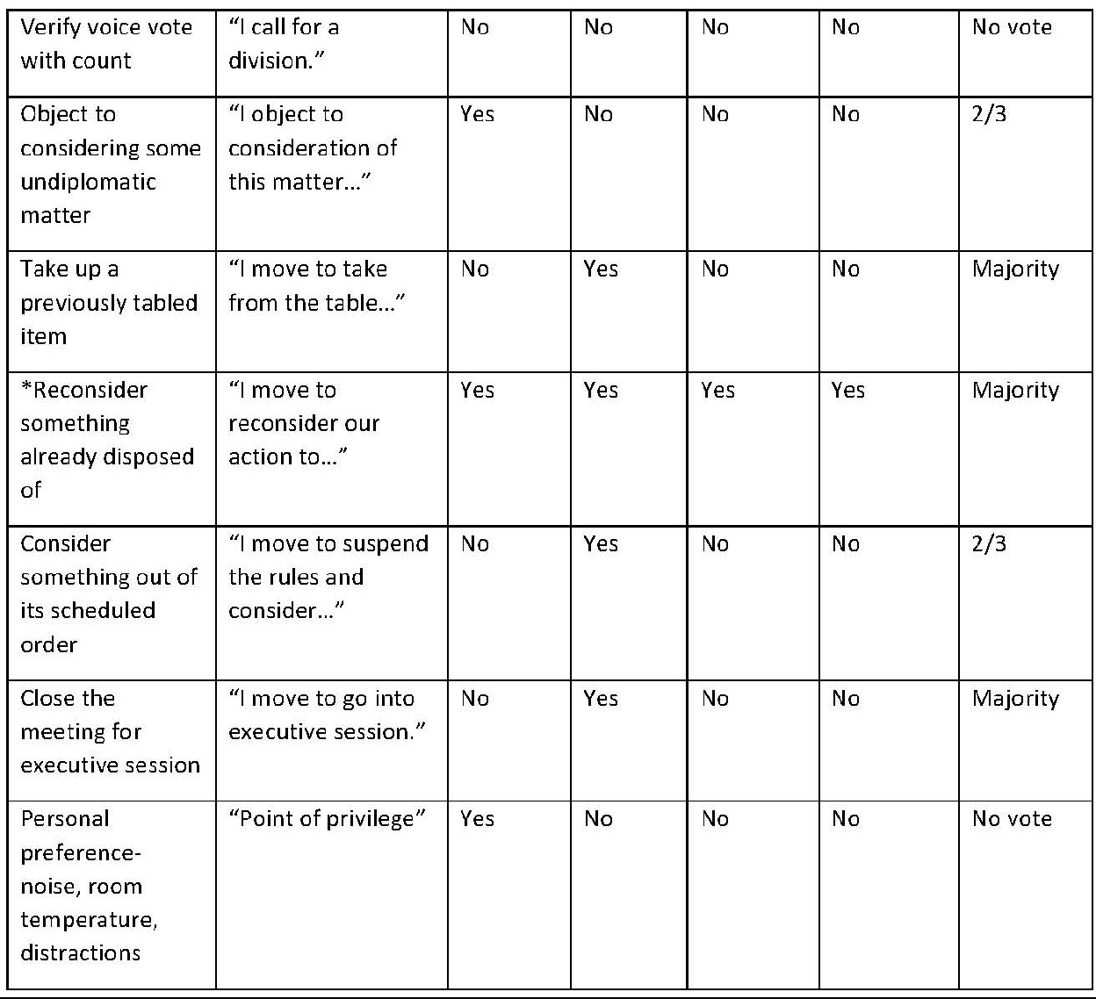

References
- Handbook for Municipal Officials, Michigan Municipal League; July 2015; https://www.mml.org/pdf/resources/publications/ebooks/HMO%20-%20complete%20book.pdf
- Handbook for General Law Village Officials, Michigan Municipal League; November 2017; http://www.mml.org/pdf/resources/publications/ebooks/GLV%20Handbook%20-%202017.pdf
- Meetings: Agenda and Minutes A handbook for municipal officials, Michigan Municipal League; 2017;
http://www.mml.org/pdf/resources/publications/ebooks/Meeting%20Agendas%20And%20Min utes.pdf
- Michigan Open Meetings Act Handbook, State of Michigan; 2018; https://www.michigan.gov/documents/ag/OMA_handbook_287134_7.pdf
- Robert’s Rules of Order Cheat Sheet for Nonprofits by Nick Price, Boardeffect.com; April 13, 2018; https://www.boardeffect.com/blog/roberts-rules-of-order-cheat-sheet/
- City of Grosse Pointe Park City Charter
- National League of Cities
- ICMA
- Grand Ledge, Portland, Davison, Traverse City, Port Huron, and Grosse Pointe City

