Dear water user,

The City of Grosse Pointe Park is committed to increasing the quality of the existing water system by replacing water mains and non-compliant water service lines. As part of this commitment, the City follows the requirements put in place by the Michigan Department of Environment, Great Lakes and Energy (EGLE), to inventory and plan for the most efficient water system upgrades.

EGLE requires that each community in the State of Michigan perform physical verifications of a portion of their water services in their community to confirm the pipe material. In response, the City has pursued and received a Community Technical, Managerial, and Financial (TMF) Support for Lead Line Replacement grant.

In order to meet the requirements of the Complete Distribution System Materials Inventory, a water service must be physically verified in three locations on the water service; location 1-3 of the following diagram.
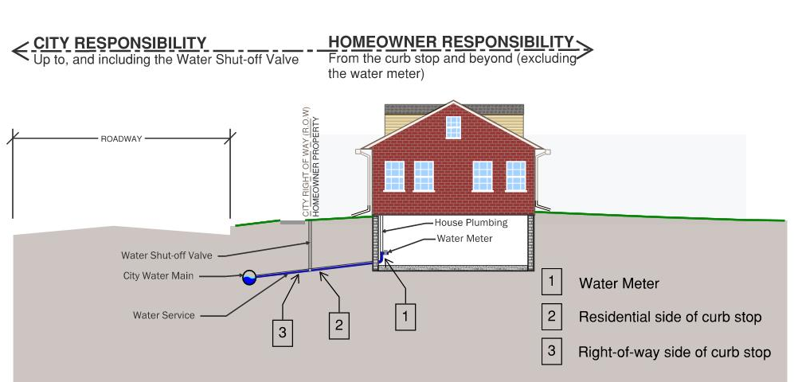

Using the TMF Grant, a physical verification of the material of the water service to your home was performed. The City of Grosse Pointe Park has determined that your entire water service is made of non-lead material, such as copper or Plastic.

If you have any questions, please reach out to the City’s DPW at (313) 822-5100.

Thank you,

City of Grosse Pointe Park Department of Public Works

