Dear water user,

The City of Grosse Pointe Park is committed to increasing the quality of the existing water system by replacing water mains and non-compliant water service lines. As part of this commitment, the City follows the requirements put in place by the Michigan Department of Environment, Great Lakes and Energy (EGLE), to inventory and plan for the most efficient water system upgrades.

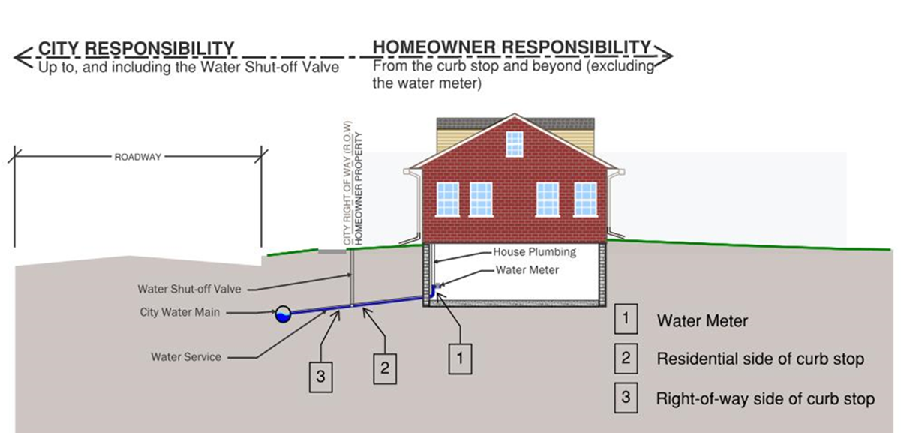
EGLE requires that the community keep an inventory of the service line material for each service in the system. EGLE considers all services that are not physically verified in locations 1, 2, & 3, in the below diagram, to be “unknown” material.

Based on record information and verified service material of houses built in the same time period as your home, it is predicted that your service is lead or galvanized (previously connected to lead). People living in homes with a lead service line may have an increased risk of exposure to lead from their drinking water.

Biannual water tests are performed at 60 homes in the City with lead water services and the results have been within the allowable limits. Great Lakes Water Authority (GLWA), the city’s water supplier, has been adding an anti-corrosive additive, orthophosphate, to the water supply since 1996. Orthophosphate act as a “water’s bodyguard’, forming a protective layer within pipes to prevent metals such as lead, iron and copper from dissolving in the water. GLWA is under the regulatory requirements of EGLE. More information regarding the City’s Annual Water Quality Report can be found on the City’s website at the following link: https://www.grossepointepark.org/307/Water-Quality-Report

Health effects of lead
Exposure to lead in drinking water can cause serious health effects in all age groups. Infants and children can have decreases in IQ and attention span. Lead exposure can lead to new learning and behavior problems or exacerbate existing learning and behavior problems. The children of women who are exposed to lead before or during pregnancy can have increased risk of these adverse health effects. Adults can have increased risks of heart disease, high blood pressure, kidney, or nervous system problems
Steps you can take to reduce lead in drinking water.
Below are recommended actions that you may take, separately or in combination, if you are concerned about lead in your drinking water. The list also includes where you may find more information and is not intended to be a complete list or to imply that all actions equally reduce lead in drinking water.
- Use filters properly. Using a filter can reduce lead in drinking water. If you use a filter, it should be certified to remove lead. Read any directions provided with the filter to learn how to properly install, maintain, and use your cartridge and when to replace it. Using the cartridge after it has expired can make it less effective at removing lead. Do not run hot water through the filter. For more information on facts and advice on home water filtration systems, EPA has developed at
https://www.epa.gov/water-research/consumer-tool-identifying-point-use-and-pitcher-filters-certified-reduce-lead
- Clean your aerator. Regularly clean your faucet’s screen (also known as an aerator). Sediment, debris, and lead particles can collect in your aerator. If lead particles are caught in the aerator, lead can get into your water.

- Use cold water. Do not use hot water from the tap for drinking, cooking, or making baby formula as lead dissolves more easily into hot water. Boiling water does not remove lead from water.

- Flush your water before use. The more time water has been sitting in pipes providing water to your home, the more lead it may contain. Before drinking, flush your home’s pipes by running the tap, taking a shower, doing laundry, or doing a load of dishes.
- Learn about construction in your neighborhood. Contact us at (313) 822-5100 or check the City’s website to find out about any construction or maintenance work that could disturb your service line. Construction may cause more lead to be released from a lead service line or galvanized service line if present.
- Check for other sources of lead. In addition to your water service line, plumbing in your home may contain lead and could increase the levels of lead in your drinking water. These may include faucets, valves and soldered joints. It is recommended that homeowners contact a licensed plumber and have a plumbing assessment completed on their homes to determine if your in-home plumbing is a source of lead in your drinking water. For information on sources of lead that include service lines and interior plumbing, please visit https://www.epa.gov/ground-water-and-drinking-water/basic-information-about-lead-drinking-water#getinto.
- Have your water tested. If you wish to have your water tested, call your water supply or use a certified lab. To find a certified lab, go to Michigan.gov/EGLElab and click certifications.

Get your child tested to determine lead levels in their blood.
A family doctor or pediatrician can perform a blood test for lead and provide information about the health effects of lead. State, city, or county departments of health can also provide information about how you can have your child's blood tested for lead. The Centers for Disease Control and Prevention recommends public health actions when the level of lead in a child’s blood is 3.5 micrograms per deciliter (µg/dL) or more. Please visit https://www.cdc.gov/nceh/lead/advisory/acclpp/actions-blls.htm for information on these actions.

If you have any questions, please reach out to the City’s DPW at (313) 822-5100.

Thank you,

City of Grosse Pointe Park Department of Public Works

