Grosse Pointe Park State of the Infrastructure Statement July 2025
The GPP Infrastructure Committee set targets for informing the community with an annual summary of our infrastructure projects, planned budget, prioritization of short- and long-term goals, as well as insight and definitions of some of our systems.

2025 In Review (to Date)
Fiscal year 2025 has seen ongoing capital investment into the core infrastructure of Grosse Pointe Park. With the Capital Improvement Plan framework, the city now follows a comprehensive long-term plan for systematic upgrades and the Water Reliability Survey that was recently presented to the city clearly demonstrates the progress being made.
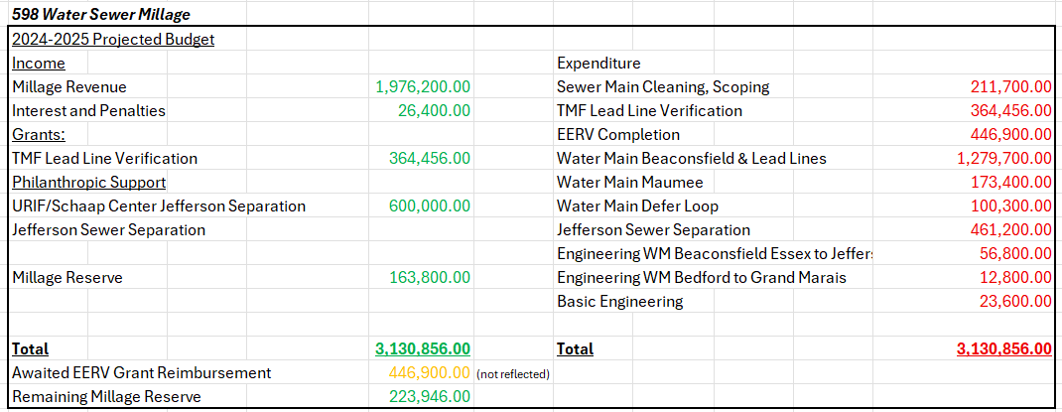
*this spreadsheet reflects Water Sewer millage capital expenditures only and is subject to change
Capital Improvement Plan:
Grosse Pointe Park City Council adopted a 6-year Capital Improvement Plan. This allows for predictability, transparency and accountability to the residents through long-term proactive planning as well as broadening regional and government support opportunities. Within this plan is incorporation of a district map, which allows for multi-year planning for ongoing public works projects, such as sidewalk work. tree trimming, sign replacement, etc.

Water/Sewer:
The largest Water Main / Lead Line Replacement Project for the city to date has been completed with the upper Beaconsfield project. 78 lead service lines were replaced along with the Water Main which has increased water capacity and reliability in surrounding areas. The Maumee Water Main Project was completed, replacing a problematic section that had caused substantial water losses. Finally, a Water Main loop was installed to provide Defer School with backup water supply to ensure that a localized Main break will no longer disrupt school service. The water reliability survey is already reflecting greater water capacity and improved service not only to these water main sections but the immediate surroundings as well.
The Jefferson Separation Project (from Wayburn to Lakepointe) is effectively completed, with only some aesthetic reclamation work to still be completed. This was the largest remaining separation project still available to the city. It resulted in substantial drying of the sewer system in a critical geographic hub of water flow and retention. This project was made possible through the philanthropic support of the URIF in support of the Schaap Center. The project, coupled with completed alleyway separations, the St Clair Montefalco Separation among other work has compounding effects reducing flooding risks to residents. There are a few isolated areas that will be targeted in the coming years, but our projections are in the last 4 years approaching half of the unseparated areas have now been separated and the city is enjoying close to 95% separation, further bolstered by the downspout disconnection program.
The city has utilized the Technical, Managerial and Financial Support for Lead Service Line Replacement Grant (TMF LSLR) from Egle to further build on our mapping of lead service lines, and this is informing our ongoing CIP driven Water Main Replacements.
The Annual Sewer Cleaning and Mapping Program continues to build out the sewer models, which slots into the Capital Improvement Planning and Sewer Cleaning in the previous year has removed 221.9 tons or 158.5 cubic of debris, put another way that is more than 13 dump trucks of debris removed from our sewer system, allowing optimized water flow.
The Extreme Emergency Relief Valve is fully operational, and a dedication was held honoring the support of the community and philanthropy to make it possible.

Roads, Alleyways, Sidewalks, Streetscapes
The sidewalk program for District 1 has been completed.
Resurfacing of Charlevoix from Cadieux to Whittier, Middlesex between Windmill Point Drive and Korte as well as alleyways on the 1100 blocks of Beaconsfield and Nottingham and between the 1300 blocks of Wayburn and Maryland have been completed.

2025-26 Goals
This summer is kicking off with the completion of the Jefferson Separation Project, the commencement of our next phase of Water Main Projects, Roadway Resurfacing and with the adoption of the budget the initiation of our Water Meter Replacement Program and First Wave of Critical Sewer Relining.

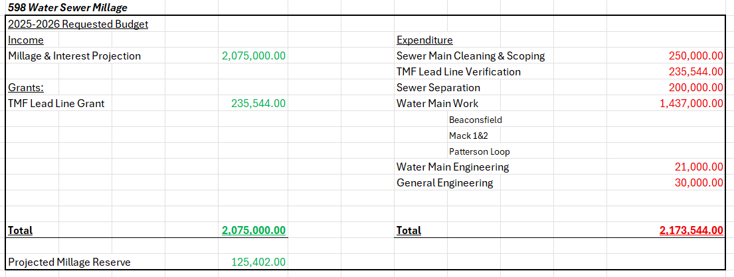
*this spreadsheet reflects Water Sewer millage capital expenditures only and is subject to change
Water/Sewer:
A city-wide water meter replacement program will be undertaken this year. This will not only replace the 75% of old obsolete meters but will replace them with modern automated radio read meters, older meters will also receive reader upgrades. This will allow for real time up to date remote reading of water usage, not only providing residents accurate instant reads, but can also be utilized to identify and isolate leaks. This effort will greatly streamline DPW water department allowing for more efficient resource allocation but will also address the substantial water losses that were identified in the water reliability survive, fully implemented this will yield significant savings to the city and residents.
The first phase of critical sewer re-lining is expected to begin this year. Targeting the approximately 4 miles of Priority 1(most in need of repair) sewers and critical manholes that have been identified through our cleaning and scoping program. This is not isolated to one area of the city, the program covers all districts of the city, with at least one repair identified on every single street in Grosse Pointe Park. Through this critical preventative maintenance, we can ensure good system operations for residents and massively reduce the risk of extremely costly and disruptive catastrophic failures.
A new sewer vacuum/jetter truck will be acquired to continue with the proactive maintenance of our sewer system.
Water Main and Lead Line Replacement for this cycle will begin in the first half of fiscal year 25/26, comprising of 4 primary sections, Beaconsfield from Jefferson to Essex, Mack Avenue from Berkshire to Buckingham, Mack Ave from 3 mile to Audobon and the main under Patterson pumping coupled with the installation of a loop. A new supplemental water main is planned under the Charlevoix streetscape project to further build up water pressure and water quality for surrounding users.

Roads, Alleyways, Sidewalks, Streetscapes
The Sidewalk Replacement Program will be moving on to district 2 this upcoming year.
Alleyway replacement work will be targeting portions of Maryland and, Wayburn between Vernor and Charlevoix as well as Kercheval and St Paul alleyways between Nottingham and Beaconsfield will be targeted.
The Charlevoix streetscape program is underway with most of the planning completed. The targeted commencement is currently expected in April of 2026. This project will include adding curb bump outs, sustainable plantings, art, narrowing roadway/traffic congestion and greater pedestrian lanes and space.
Resurfacing of Charlevoix between Berkshire to Three Mile is expected later in 2025.
Windmill Pointe Rear Park will be resurfaced between 3rd and 4th quarter of 2025.
Additional localized and targeted road spot repairs are planned throughout the city during the coming months.

Energy and Sustainability
The city anticipates significant water savings from implementation of new water meters, the reduction of water infiltration in the sanitary system and the reduction in losses due to ongoing water main replacements. Furthermore, the upgraded system will help leak detection for residents; Eventually the DPW will be able to provide real-time feedback at resident request regarding discrepancies.
The city continues to pursue grant opportunities as well as investigating if the federal grant support for the EERV may be utilized in upgrades to the pumping station to potentially install variable frequency drives to make the pumps more energy efficient as well as improving resilience and responsiveness of the system.
Once the resurfacing of the rear windmill pointe parking lot is completed, the city is investigating options for protected overflow lot storage for supplies and salt, to reduce potential runoff.

